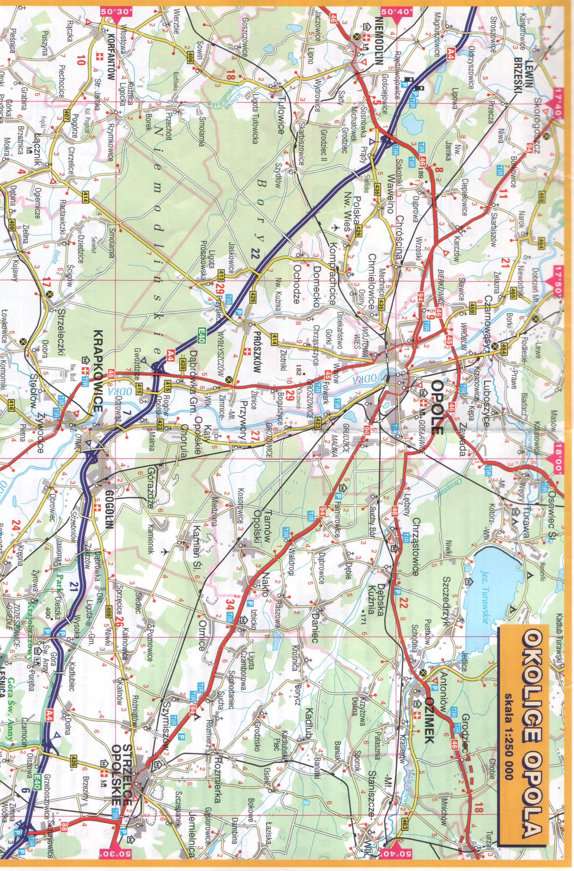

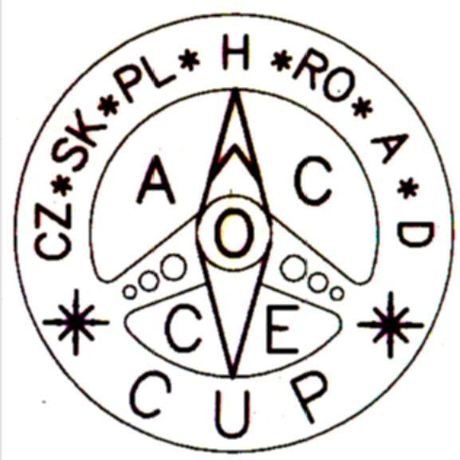
The Central
European
Cup

Navigation Rally

KARLIK ‘ 2 0 1 4

Opole - Turawa, May 16th -18th, 2014

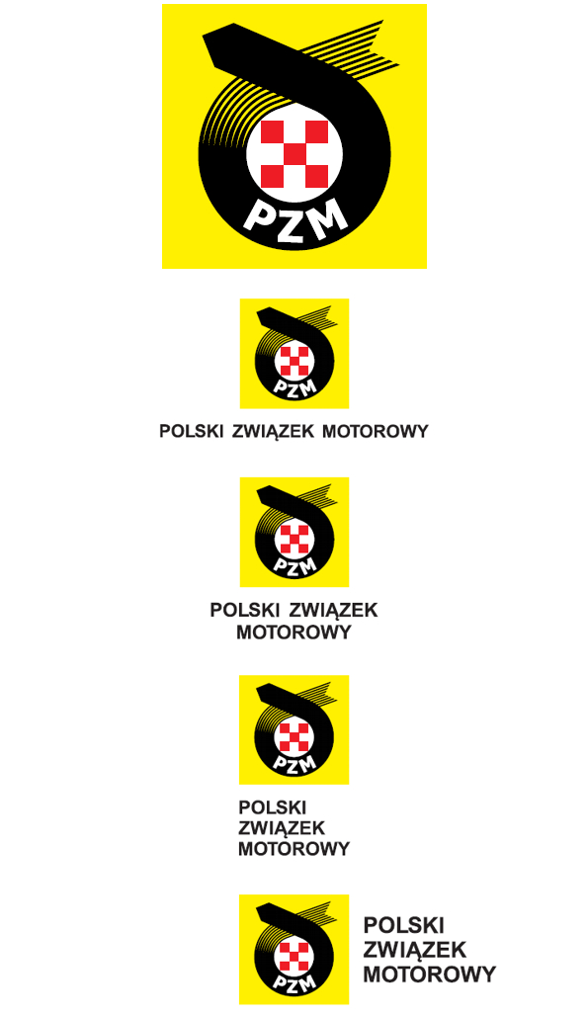

Polish
Navigation
Motorcar
Championship

Administration PZM at Opole and Opolskie Stowarzyszenie Automobilistów would wish to invite to Navigation Rally KARLIK’2014, held on May 16th-18th, 2014, organised under the auspices of the General Commission of Popular Sports and Tourism PZM. Rounds Ist and IInd of Polish Navigation Motorcar Championship as well as the Ist and IInd round of Central European Cup will take place during KARLIK’2014. The rally will be held in accordance to the binding rules of Polish Navigation Motorcar Championship.

Rally Administration:
President of Opolskie Stowarzyszenie Automobilistów - Henryk Punt
Rally Commander - Marek Pańka
Administrative Vice-Commander - Mirosława Babiak
Route Authors - Andrzej Morel, Wojciech Czuczwara
- Henryk Punt, Małgorzata Punt
Assessment Commission - Irena Pańka, Rafał Kamiński

Route verification - Marek Pańka
- Marek Czmielewski

Rally Base: Turawa ul. Spacerowa 2, Resort PETERS

Rally Programme:

16-05-2014 (Friday)
15:00 - 18:00 – competitors admissions (Resort JOWISZ)
18:00 – 18:45 - supper
19:45 -KARLIK’2014, Opening Ceremony
20:00 -24:15 - Ist round of European Cup, NIGHT stage

17-05-2014 (Saturday)
7:00 - Ist round unofficial scores
7:45 - 8:30 - breakfast
9:15 - 14.45 IInd round of European Cup, DAY stage
14:30 - 15:30 - lunch
16:00 - 18:00 - tourist part

18:30 - IInd round unofficial scores
20:00 - dinner (PETERS)
21:00 – Rally official scores, prize awarding

18-05-2014 (Sunday)
8:30 - breakfast
10:00 - Event’s end

Applications:

Participants should submit their applications before 05-05-2014r
by sending their APPLICATON FORM to:

Opolskie Stowarzyszenie Automobilistów
45-231 Opole ul. Oleska 125a
POLAND

or by e-mail: osaopole@poczta.fm

Each of team (driver and pilot) that applied to The Central European Cup is to pay 100,- EUR on the first day of event. Every additional person has to pay 50,- EUR
For more information check: http://osaopole.fm.interia.pl/
A detailed Rally programme confirming participation will be sent to the applicants.

For detailed information call:
Henryk Punt +48 883 310 211
Marek Pańka +48 604 073 345
Andrzej Morel +48 502 522 689 – speaks English

President
Rally Commander of Opolskie Stowarzyszenie
Automobilistów

Marek Pańka Henryk Punt

